# Coeur Business Analysis

Total number of records = 4107

|  |  |
| --- | --- |
| Customer_type | Count |
| Customer | 4007 |
| Ambassador | 89 |
| Professional | 5 |

# Analysis of customer data

Total distinct zip codes = 2745

As we can see in graph , 95.6 % Zip locations have only 1-3 customers where as only 0.2% zip locations have 9-13 customers.

Below map shows customer density in different zip codes. There is too much overlap in zip code locations.

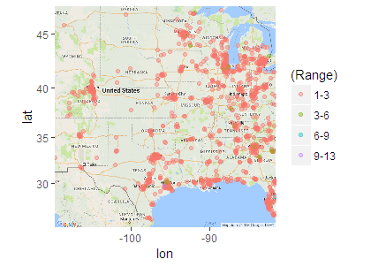

**Analysis:**

**1. As we can see 95.6% zip codes have only 1-3 customers which is not statistically significant. So drawing any conclusion will be highly skewed and might be wrong.**

**Proposed Solution:**

**1. You can provide more data to draw conclusions about zip codes.**

**2. We can shift our analysis point to city level instead of zip codes. In this way we can get sufficient customer base for our analysis.**

**#State Level**

